End users started out with the following security profiles:

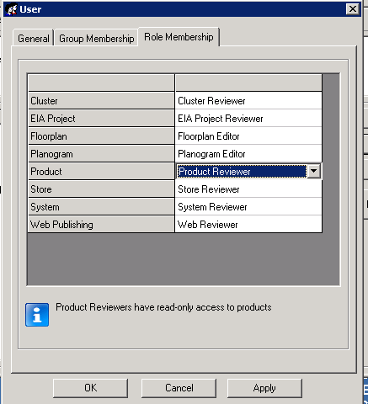

With the requirements that they needed, change OLC for POGs, update Product library (for product measurements) etc. we’ve had to modify their login security profiles.

It was trial and error until we could find the appropriate security settings needed
so the users can do the tasks required.

From Floorplan Editor – Floorplan Creator – Floorplan Author
From POG Editor – POG Creator – Floorplan Author
From Product Reviewer - Product Editor

Here are some requirements that the US merchandising managers required when we created their accounts, we’ve also changed a couple of security profile..

- Ability to change POG lifecycle (see fig 11)
We had to modify this from the SQL back-end, the console front end rights didn’t provide this ability for the end user
- Ability to update Product library for product measurements (changed product reviewer to product editor profile)
- Ability to create new Floorplans in JDA (changed Floorplan editor to Floorplan Author)
- Ability to change OLC for Floorplans (see fig 11)

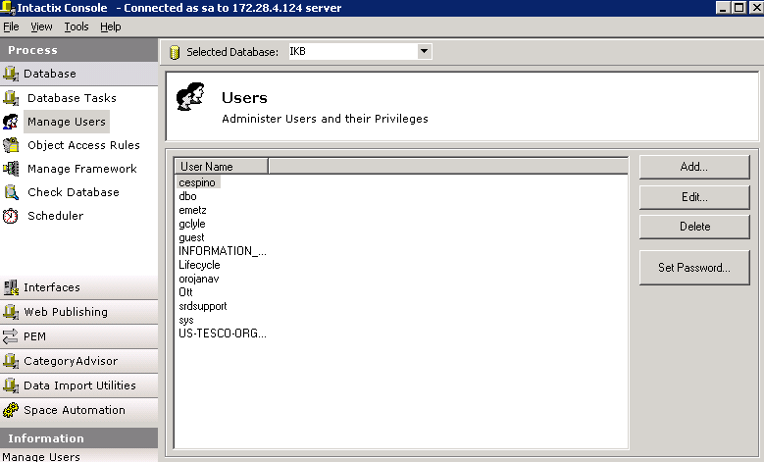
(fig 1)

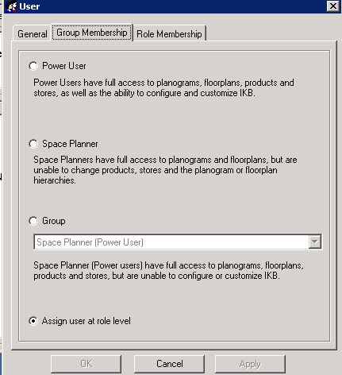
(fig 2)

Selected user “emetz”

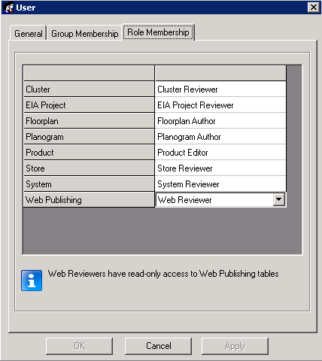
(fig 3)

Selected for user “emetz”
Floorplan – Floorplan Author
Planogram – Planogram Author
Product – Product Editor

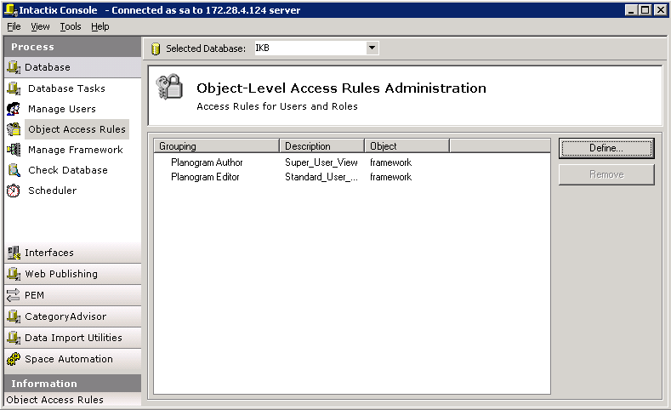
(fig 4)

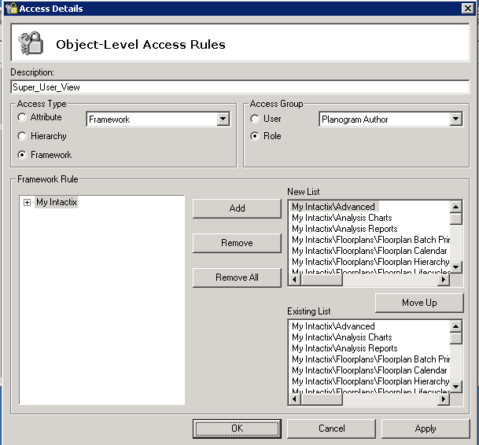
(fig 5) Planogram Author Role

We’re still trying to understand the access rights for this.

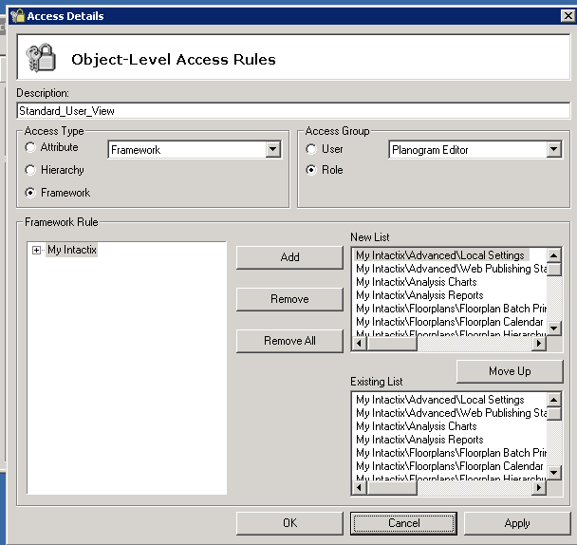
(fig 6) Planogram Editor role

We’re still trying to understand the framework rules

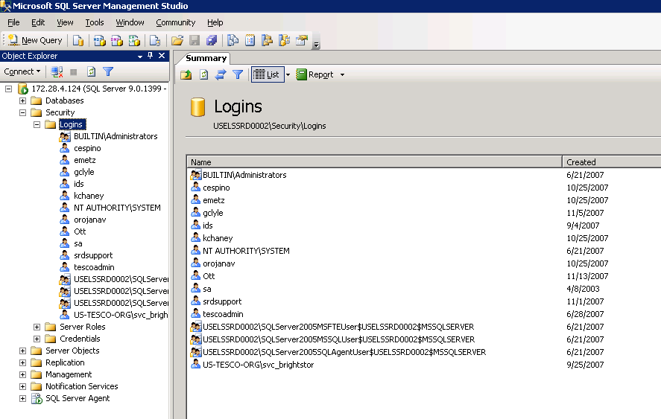

(fig 7) SQL Server management Studio

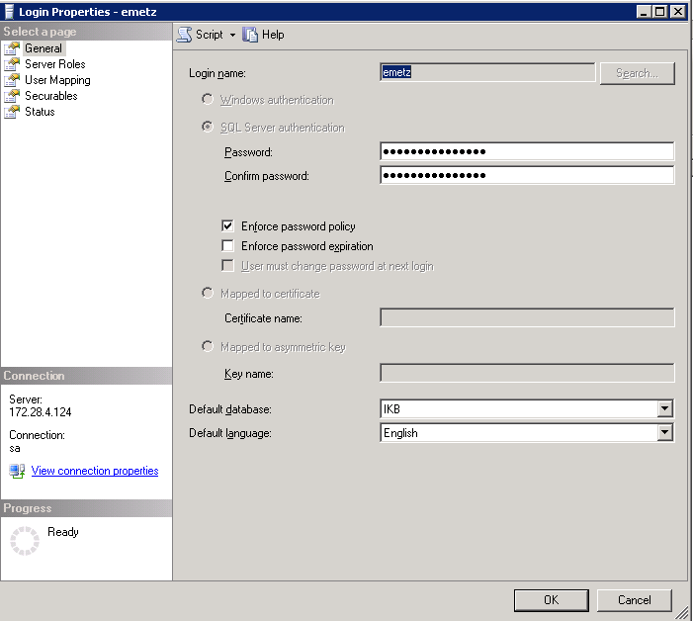
(fig 8) “emetz” properties

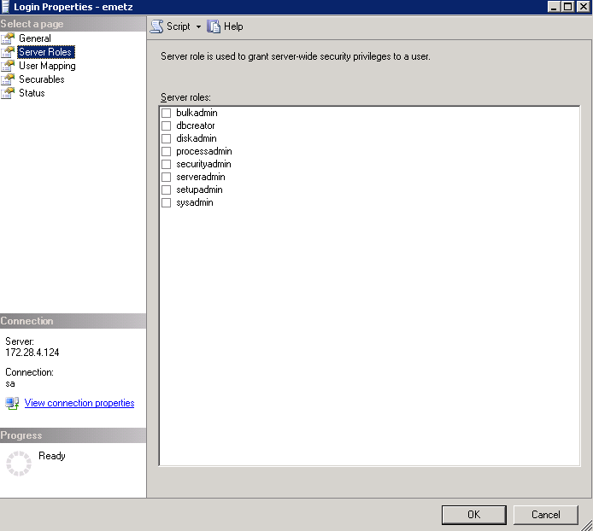
(fig 9) “emetz” server roles

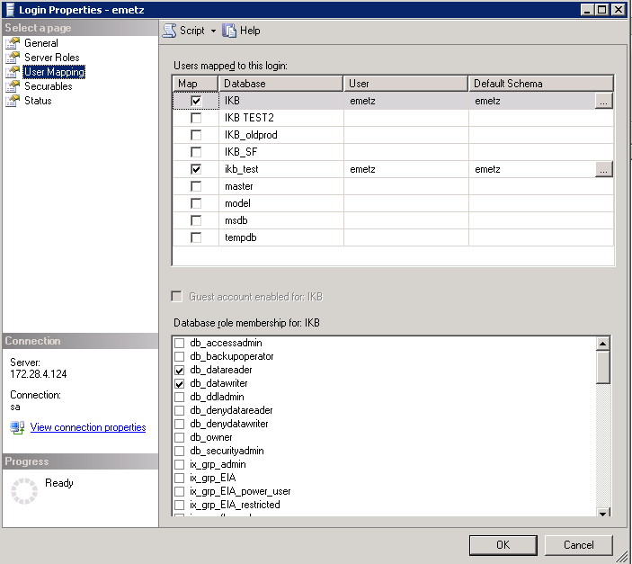
(fig 10) role membership

Selected
Db_datareader
Db_datawriter

Per Carla Goodwin (JDA), these need to be manually checked after the accounts are created

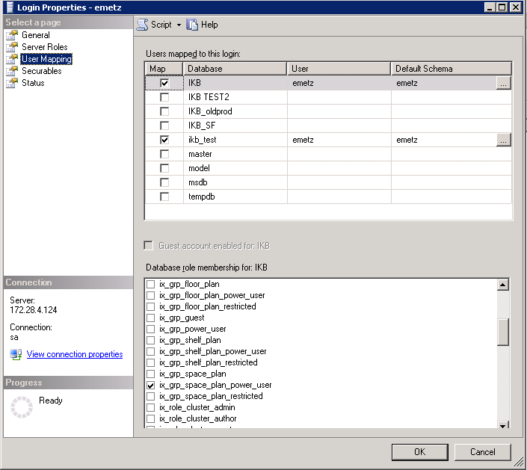
(fig 11)

Selected
Ix_grp_space_plan_power_user
Ix_grp_floor_plan_power_user

End users need to change the POGs lifecycle, the default console setup didn’t provide that option. We had to manually enable Ix_grp_space_plan_power_user for the users to change the POGs lifecycle.

End users need to change the Floorplans lifecycle, the default console setup didn’t provide that option. We had to manually enable Ix_grp_floor_plan_power_user
for the users to change the Floorplans lifecycle.

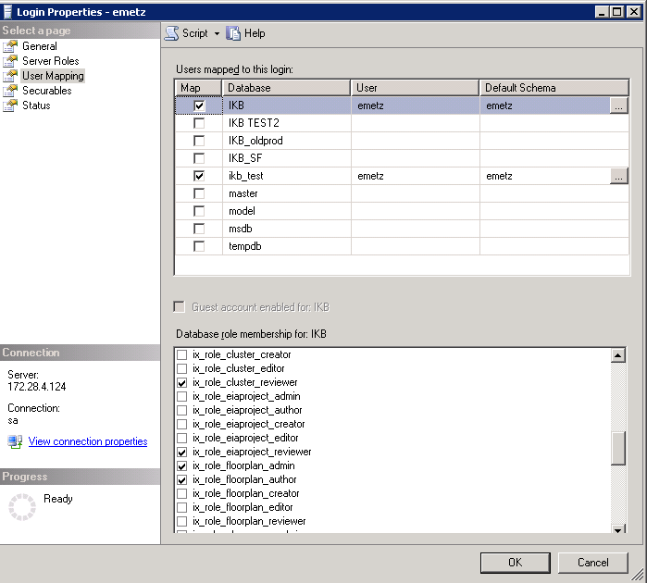
(fig 12) default setting for user, no changes done

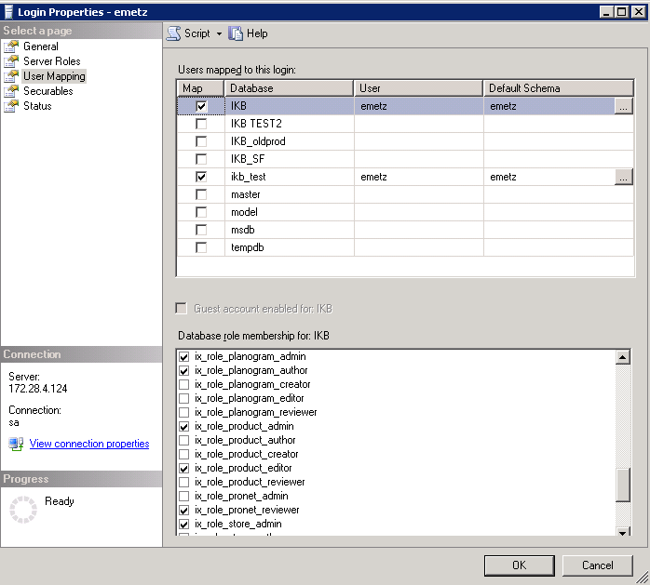
(fig 13) nothing changed here either

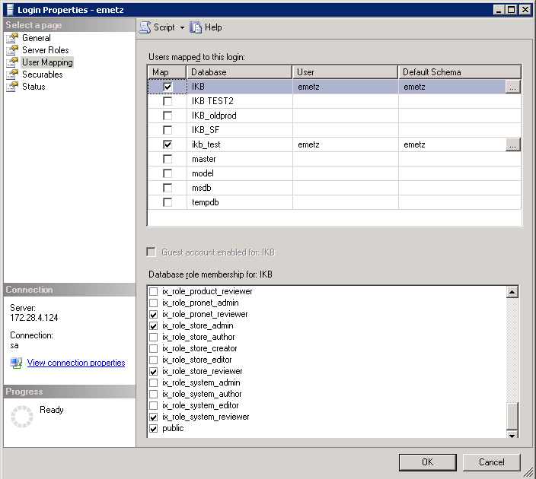
(fig 14) nothing changed here either

